1. Beginner Level — The Foundations

✅ 1.1 JavaScript Basics
Learn what JS is and how it runs.
- What is JavaScript?
- JS in Browser vs JS in Node.js
- How JavaScript is executed (JS Engine, Runtime)

JavaScript is a high-level, dynamic programming language mainly used to make websites interactive.
If HTML is the structure, and CSS is the design, then JavaScript is the brain of a webpage.
Here is a simple breakdown 👇

⭐ What JavaScript Actually Is
JavaScript (JS) is:
- A programming language used to add logic and behavior to web pages.
- A client-side language (runs in the browser) — but can also run on servers using Node.js.
- One of the core technologies of the web along with HTML and CSS.

⭐ What JavaScript Can Do
JavaScript can:

✔ Add interactivity
Buttons, sliders, popups, animations, dropdowns, etc.

✔ Update content dynamically
Without reloading the page — this is how modern sites/apps work.

✔ Communicate with servers
Using APIs, AJAX, Fetch, WebSockets.

✔ Build full applications
With the help of frameworks like:
- React.js
- Vue.js
- Angular
- Mobile apps using React Native
- Server apps using Node.js

⭐ Where JavaScript Runs
JavaScript can run in:
- Any web browser (Chrome, Firefox, Safari, Edge, etc.)
- Servers using Node.js
- Mobile apps, desktop apps, IoT devices, etc.

⭐ Example of JavaScript Code
// Simple JavaScript Example
function greet(name) {
console.log("Hello " + name);
}

greet("Sachin");

⭐ Why JavaScript Is Important
- It is the most popular programming language in the world.
- Required for frontend development.
- Essential for full-stack development.
- Used in many modern technologies (web, AI tools, automation, mobile apps).

⭐ In Simple Words
👉 JavaScript makes websites come alive.
👉 Without JavaScript, websites would be static and boring.

Here is the clear, simple, and complete explanation of JavaScript in Browser vs JavaScript in Node.js with visuals and examples.

🌐 JavaScript in the Browser vs 🟩 JavaScript in Node.js
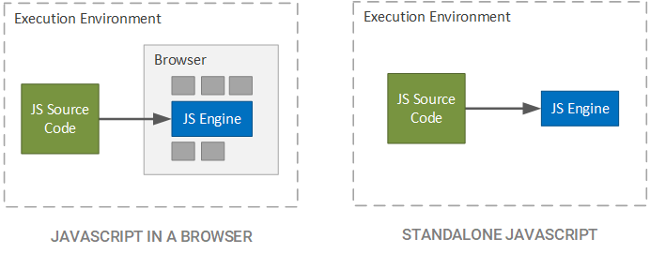
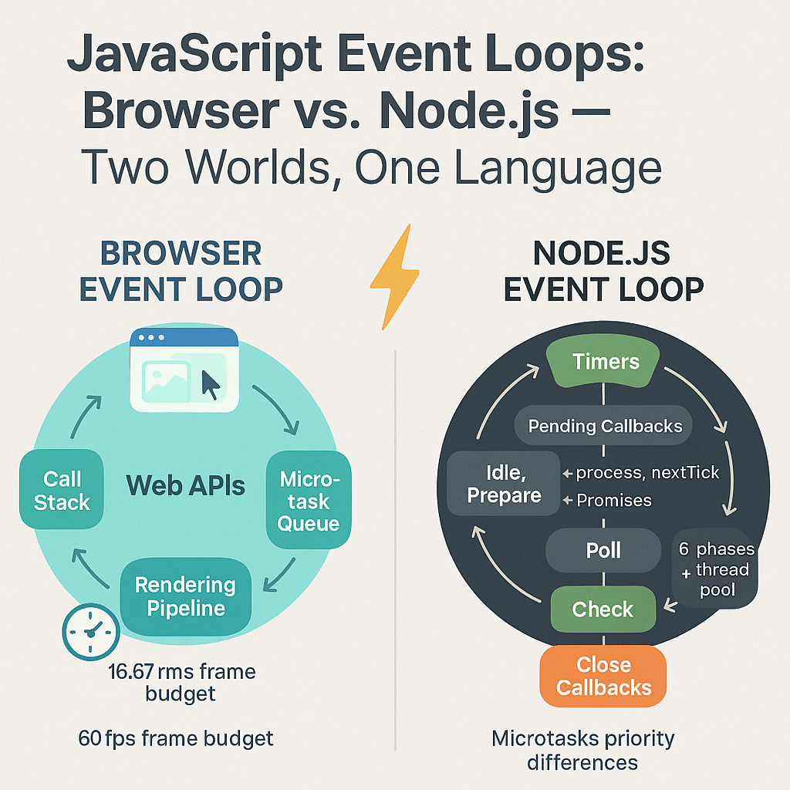

6

🔥 1. What’s the Main Difference?
Feature | JavaScript in Browser | JavaScript in Node.js
Runs where? | In the user's web browser | On a server or local machine
Purpose | Build UI, make pages interactive | Build backend, APIs, command-line tools
Environment | DOM + Browser APIs | File system, OS, network APIs
Who controls execution? | Browser (e.g., Chrome, Firefox) | Node.js runtime
Security | Highly restricted | Fewer restrictions
Modules | ES Modules (import/export) | CommonJS (require), ES Modules too
Global object | window | global

🔥 2. JavaScript in the Browser
The browser mainly focuses on UI + interactions.

It provides special Web APIs like:
- DOM (document.getElementById)
- BOM (window, history)
- fetch() for API calls
- localStorage / sessionStorage
- alert(), prompt()

Example (Browser JS):
document.getElementById("btn").onclick = function () {
alert("Button clicked!");
};
👉 This works only in browsers because Node.js does not have a DOM.

🔥 3. JavaScript in Node.js
Node.js is used for backend development, not UI.

Node provides powerful system-level APIs:
- File system (fs)
- Networking (http)
- Operating system access (os)
- Databases (MongoDB, MySQL)
- Running servers

Example (Node.js):
const fs = require("fs");

fs.writeFileSync("test.txt", "Hello from Node.js");
👉 This works only in Node.js, because browsers cannot access your file system directly (for security).

🔥 4. Global Objects Difference

Browser:
console.log(window);

Node.js:
console.log(global);

🔥 5. Module System Difference

Browser JS:
import user from "./user.js";

Node.js (CommonJS):
const user = require("./user");

🔥 6. API Differences
Task | Browser JS | Node.js
Access DOM | ✔ Yes | ❌ No
Access Files | ❌ No | ✔ Yes
Build Backend | ❌ No | ✔ Yes
Run Server | ❌ No | ✔ Yes
Access localStorage | ✔ Yes | ❌ No
Use Fetch API | ✔ Yes | ✔ Yes (newer Node versions)

🔥 7. Why Both Exist?
- Browser JS = Frontend
- Node.js = Backend using JavaScript
This makes JavaScript a full-stack language, which is why it’s so popular.

🎯 Summary in One Line
👉 Browser JavaScript = UI + Interaction
👉 Node.js JavaScript = Backend + Server Logic

Bottom of Form

Here is a clear, beginner-friendly AND advanced explanation of how JavaScript is executed — including JS Engine, Runtime, Call Stack, Event Loop, Memory Heap, Web APIs, etc.
This is the explanation interviewers expect.
I’ve also added helpful diagrams 📊 for easy understanding.

🚀 How JavaScript Is Executed (JS Engine + Runtime)
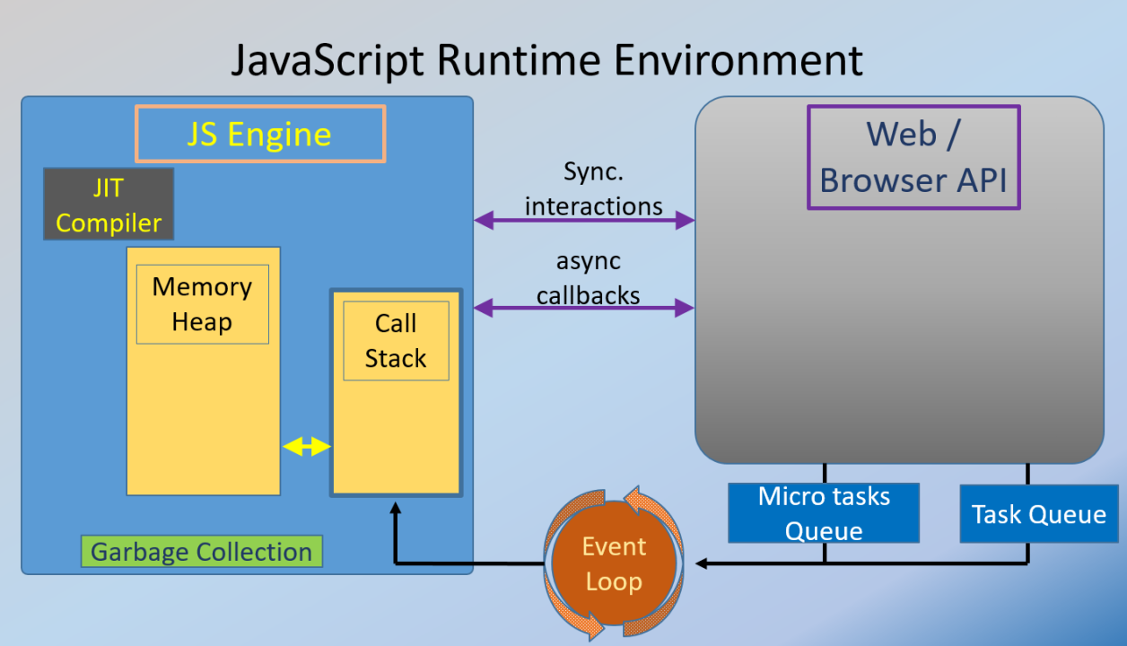
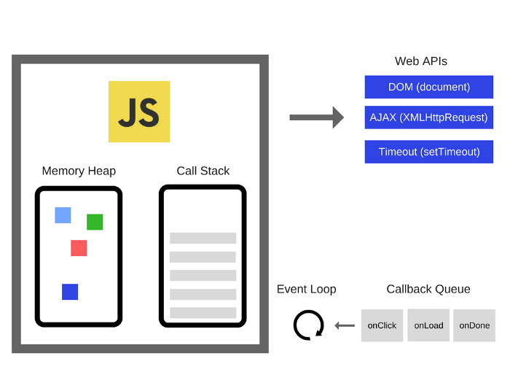
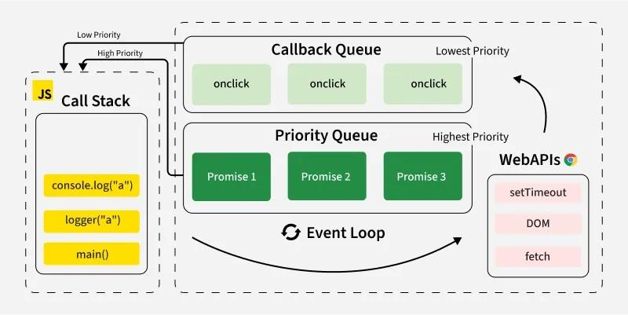

JavaScript execution involves two main systems:
1️⃣ JavaScript Engine (e.g., V8, SpiderMonkey)
2️⃣ JavaScript Runtime (Browser Runtime or Node.js Runtime)

🧠 1. What is a JavaScript Engine?
A JavaScript Engine is a program that reads and executes JavaScript code.
Popular engines include:
- V8 (used by Chrome & Node.js)
- SpiderMonkey (used by Firefox)
- JavaScriptCore (Safari)
Each engine has two key parts:

🔹 (a) Memory Heap
Where variables & objects are stored.

🔹 (b) Call Stack
Where functions are executed line by line (LIFO: Last In First Out).

⚙️ 2. Steps of Execution Inside JS Engine
Here’s exactly how JS code runs:

🔥 Step 1: Code Parsing
The engine reads your JS code and checks syntax.

🔥 Step 2: Compilation (JIT Compilation)
JavaScript uses a Just-In-Time compiler:
- Interpreter → converts code quickly to bytecode
- Compiler → optimizes frequently used code (TurboFan in V8)

🔥 Step 3: Execution
- Functions enter the call stack
- Variables & objects go to the memory heap
- Engine executes line-by-line

⏳ 3. What is a JavaScript Runtime?
A runtime is an environment around the JS engine that provides extra features not part of the language.
Two major runtimes:
- Browser Runtime
- Node.js Runtime
Both include:
- JS Engine (e.g., V8)
- Event Loop
- Callback/Task Queue
- Microtask Queue
- External APIs
  - Browser → DOM, fetch(), timers
  - Node → fs, http, process, etc.

🌐 Browser Runtime Diagram

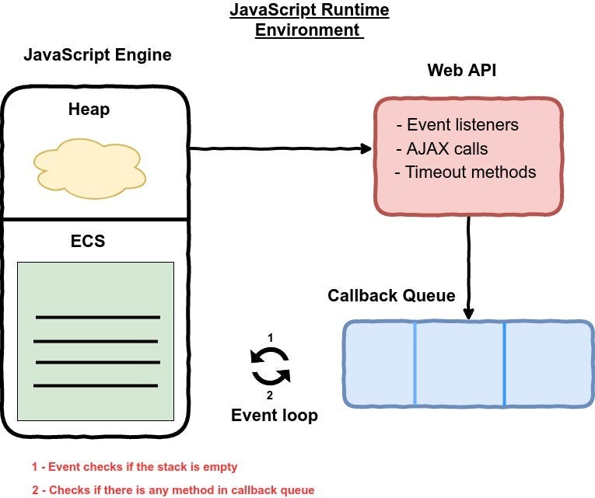
4
Includes:
- DOM APIs
- Web APIs
  - setTimeout
  - fetch
  - event listeners
  - console
- Event Loop
- Callback Queue
- Microtask Queue

🟩 Node.js Runtime Diagram
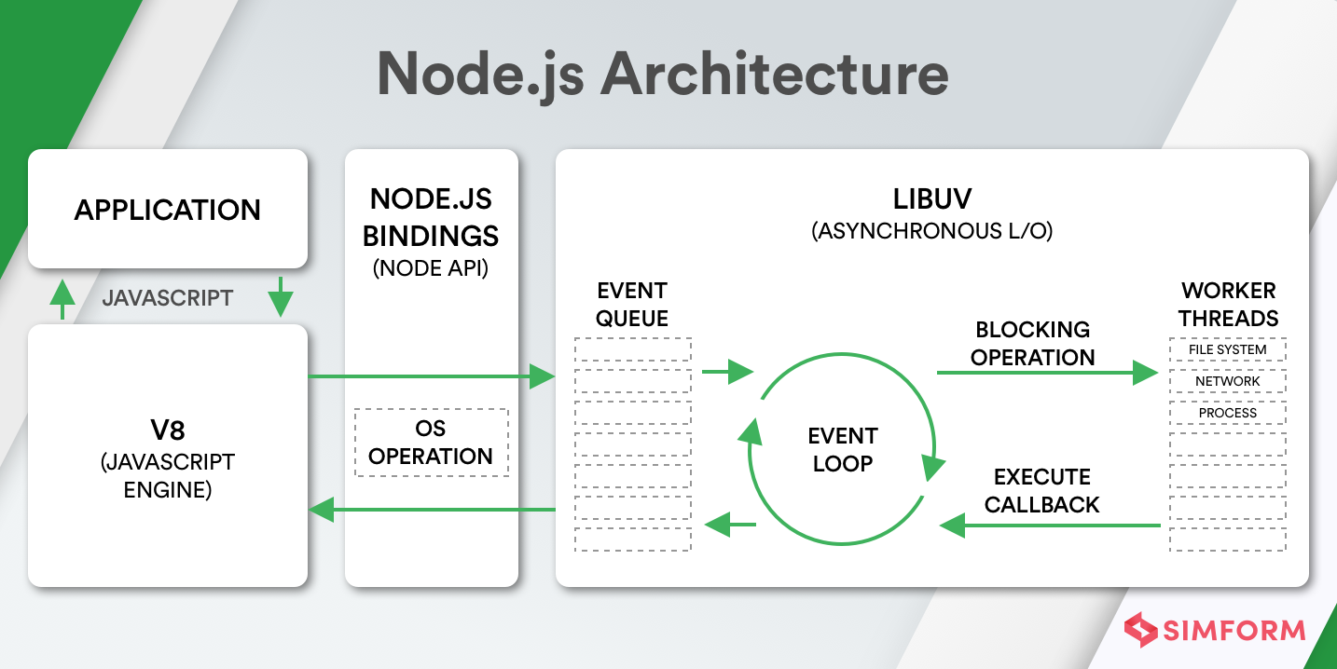

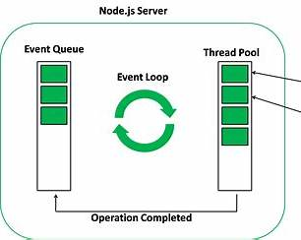
6
Includes:
- FS module
- HTTP module
- Timers
- Process.nextTick()

🔄 4. Event Loop — The Heart of JS Execution
The Event Loop decides what executes next in the call stack.

Event Loop Rules:
- If call stack is empty, push tasks from queues.
- Microtasks queue has priority over callback queue.
- Tasks run one at a time → JavaScript remains single-threaded.

🧵 5. Call Stack Example
function a() {
b();
}
function b() {
console.log("Hello");
}
a();
Execution:
Order | Stack
1 | a() pushed
2 | b() pushed
3 | console.log pushed
4 | console.log executes
5 | pop log, then b, then a

⏱ 6. async functions & Event Loop
console.log("1");

setTimeout(() => {
console.log("2");
}, 0);

console.log("3");
Output:
1
3
2
Why?
- setTimeout() goes to Web API
- Then moves to Callback Queue
- Event Loop waits until stack is empty
- Then prints 2

🧩 7. Microtasks vs Macrotasks

Microtasks:
- Promises (.then)
- Mutation observers
- process.nextTick (Node)

Macrotasks:
- setTimeout
- setInterval
- setImmediate
- I/O callbacks

Priority:
Microtasks ALWAYS execute before macrotasks.

🎯 Summary (Interview Answer)
Here is the perfect short answer:
JavaScript runs inside an engine (like V8) that contains a call stack and memory heap.
The engine parses, compiles, and executes the code.
Around the engine, the runtime provides features like Web APIs or Node APIs, a callback queue, microtask queue, and the event loop.
The event loop continuously checks the call stack and queues, ensuring asynchronous code executes in order.

